**INTRODUCTION**

[There are many cues to depth]

Depth perception is a complex process where the brain integrates different visual cues (Swanston & Wade, 2001). Most require only one eye (monocular cues) and are categorized as psychological: overlapping (interposition), perspective (conical projection), lighting-shading, chromatic attenuation and focus are the most relevant. Accommodation is categorized as a physiological monocular cue. On the other hand, binocular cues, convergence and retinal disparity, require both eyes. Retinal disparity or stereopsis arises from the concept of parallax: each eye is exposed to a slightly different image of the world that the brain must integrate into a single cyclopean perception (Wheatstone, 1838). Parallax is in the origin of a similar cue available to monocular vision, motion parallax, created by the relative motion between the observer’s head and the perceived scene.

[Humans integrate these cues optimally, suggesting that we can train observers to better rely on binocular cues.]

Given the many visual cues to integrate, humans show a statistically optimal strategy for combining visual cues to depth (Hillis et al., 2004; Knill & Saunders, 2003). This strategy has also been shown when integrating visual cues to depth with other modalities, namely touch (Ernst & Banks, 2002; van Beers et al., 2011). When sensory noise and cue conflict is relatively low, the optimal model, aimed at reducing variance (Ernst & Banks, 2002; Hillis et al., 2004; Knill & Saunders, 2003), is a linear weighted average of all cue. However, optimal integration seems to be adaptable and can be influenced through feedback (Atkins et al., 2001; Ernst et al., 2000; Jacobs & Fine, 1999), though feedback is not a requirement (Knill, 2007a). This reweighting of context-specific priors seems to be highly adaptable (Jacobs & Fine, 1999; Knill, 2007a, 2007b) and can occur at a relatively fast rate (van Beers et al., 2011). Importantly, by pairing haptic feedback with binocular cues, observers have been trained to rely on binocular disparity cues (Ernst et al., 2000; Knill, 2007b; Vedamurthy et al., 2016). Optimal cue integration and the adaptability of cue reweighing suggests that observers who lack stereovision, can indeed be trained to rely on binocular cues.

[Stereopsis is important]

Stereopsis plays a key role in extracting depth information from natural scenes (Mckee & Taylor, 2010), breaking camouflage (Adams et al., 2019), and planning and executing everyday visuomotor tasks (Melmoth et al., 2009; Melmoth & Grant, 2006). However, abnormal visual experience during the “sensitive period” of development (Banks et al., 1975; Held et al., 1980) may result in amblyopia and, as a result, in reduced or absent stereopsis (Webber & Wood, 2005). Amblyopia, the leading cause of visual loss in children, is a neuro-developmental disorder that arises from an imbalance between the ocular inputs to the visual pathway (Hess et al., 2010; Li et al., 2007). It is characterized as reduced visual acuity in an otherwise normal eye despite best optical correction (Holmes & Clarke, 2006) and is typically secondary to misalignment of the visual axis (strabismus) and/or unequal refractive error (anisometropia).

Stereopsis can be improved with laboratory training

For the overall well-being of people with amblyopia, stereopsis may be an important function to recover/ strengthen. Perceptual Learning, PL, defined as “any relatively permanent and consistent change in the perception of a stimulus array following practice or experience with this array (…)” [Gibson, 1963], has demonstrated great potential in amblyopia treatment (Levi & Li, 2009). Although functionally suppressed when viewing binocularly (Birch, 2013; Tavers, 1938), binocular stereovision mechanisms seem to be intact in people with amblyopia (Ding & Levi, 2014; Giaschi et al., 2013; Hess et al., 2014), making stereo training a viable option. Different visual stimuli have been evaluated for the direct recovery of stereoacuity when compromised by amblyopia. Stimuli range from monocular training (Li et al., 2011) to dichoptic training (Vedamurthy, Nahum, Huang, et al., 2015) and direct stereoacuity training (Jian Ding & Levi, 2011; Portela-Camino et al., 2018). It seems that one approach or stimuli type does not work for all classifications of amblyopia. Interestingly, individuals with strabismic amblyopia have a higher probability of improvement with dichoptic training compared to monocular training, and fare even better with direct training (Levi et al., 2015a). People with normal binocular vision can also benefit from training, improving their stereoacuity thresholds (Schoemann et al., 2017). However, laboratory-based paradigms require participants to sit through many hours of monotonous psychophysical training (Ding & Levi, 2011) and result in low motivation and compliance (CITE).

Video games as a home-based therapy strategy

Considering that the main drawbacks of most laboratory-based training paradigms are user compliance, attention and motivation, several authors have proposed the use of specifically designed video games to treat amblyopia both in the clinic and as a home-based therapy strategy. Gamification, i.e. the use of game principles in non-game contexts, includes the use of levels of increasing difficulty adapted to participant performance, rewards, a story line, and social context, among other aspects [references]. The relatively new widespread use of cloud storage allows remote tracking of user compliance and incoming data, addressing the importance of practitioner supervision (Holmes et al., 2016). The ease of data monitoring has made remote therapy a viable and convenient option. Several studies, including clinical trials (Gao et al., 2018), have reported benefits of using video games to treat amblyopia (Li et al., 2009; Li et al., 2011; Vedamurthy, Nahum, Bavelier, et al., 2015; Vedamurthy, Nahum, Huang, et al., 2015) and direct stimulation of stereopsis has been tested using this approach (Portela-Camino et al., 2018).

[references serious games and gamification]

* The Gamification of Learning and Instruction. Game-based methods and strategies for training and education. Karl M. Kapp. John Wiley & Sons, 2012
* Serious Games. Games that educate, train, and inform. David Michael, Sande Chen. Thomson Course Technology, 2006
* Developing Serious Games. Bryan Bergeron. Charles River Media, 2006

Recent commercialization of Virtual Reality head-mounted displays (VR-HMDs) have opened the opportunity to design therapies that incorporate gamification principles and build upon successful laboratory-based techniques such as PL and dichoptic training. VR-HMDs provide researchers and clinicians with the ability to present separate images to each eye, correct through software any misalignment due to strabismus without the need of a chin rest, and adjust contrast or luminance independently for each eye until balanced binocular vision is achieved. VR-HMDs provide a wide visual field, facilitating vergence in users with strabismus, and large disparities that may help in amblyopia treatment. Furthermore, VR-HMDs provide the ability for researchers to control depth cue content, with the exception of accommodation, which is the only cue without a commercial solution (Love et al., 2009).

The aim of this paper was to train stereo-normal and stereo-anomalous participants to rely on disparity cues, by means of two VR games that combine demanding stereovision tasks, dichoptic PL and depth cue scaffolding.

**METHODS**

**Participants**

Twenty adults (mean age: 28 ± 2.5, range: 18 – 62 years, 14 female) with normal or corrected-to-normal vision and without ocular pathologies participated the study. Participants were recruited by telephone from the Meredith W. Morgan University Eye Center’s internal list of patients who gave written consent to be contacted for research studies and through internal UC Berkeley email list serves. The study protocol was approved by the Institutional Review Board of the University of California, Berkeley. Exclusion criteria for the study included: (1) ocular pathologies (e.g., macular abnormalities) or nystagmus, (2) non-concomitant or large angle constant strabismus (> 30 prism diopter), (3) inability to fuse, (4) constant esotropia (> 20 prism diopters), (5) visual acuity (VA) ≥ 20/200, and (6) previous dichoptic visual training of more than 10 hours.

**Study design and training**

All participants underwent a complete clinical assessment before and after the study (Figure 1). The complete clinical assessment included: (1) retinal health (retinoscopy), (2) current prescription, (3) refraction at distance, (4) visual acuity (Bailey Lovey visual acuity chart), (5) ocular deviation (cover test), (6) binocular fusion (Worth Dot at 33 cm and 3 meters), and (7) clinical stereoacuity (Randot Circles Stereotest® and Random Dot 3 Stereo Acuity Test with Lea Symbols®). Participants were categorized as anisometropic if there was a difference ≥ 0.50D in spherical equivalent refraction or ≥ 1.5D difference in astigmatism in any meridian, between the two eyes (Wallace et al., 2011). Participants were classified as strabismic in the presence of tropia with the cover test.

Following the complete clinical assessment, eligible participants were placed in either the stereo-normal or stereo-anomalous group based on their initial Randot Circles Stereotest® stereoacuity measurement. Inclusion criteria for the stereo-anomalous group was baseline stereoacuity of 50 arc secs or worse. The stereo-anomalous group was made up of four participants with strabismus, four with anisometropia, one with small-angle strabismus (classified by results in the 4 BO test), and one stereo-weak, but otherwise normal (Supplemental Table 1). The ten participants in the stereo-normal group were classified as having normal binocular vision.

Figure 1. Study and training schematic. Each participant began with a complete clinical assessment. Followed by clinical and psychophysical stereoacuity tests. Participants then alternated between playing one of two games (Halloween or DartBoard) for 10 hours. After a 10 hour block, clinical and psychophysical stereoacuity tests where administered until 40 hours were completed. Lastly, a complete clinical assessment was administered.

Training was organized in four blocks, each made up of ten 1-hour sessions. Each session was divided into two 30-minute intervals to allow participants to take a break between intervals. On each 10-hour block, one of the two games designed specifically for this study was played: Halloween or DartBoard. Most participants completed 40 hours of training (4 blocks) with the exception of N2 and N4 who completed 20 hours, and AS1, AA1, N5, N7, N9, N10 who completed 50 hours total.

To monitor participant progress, before and after each training block of 10 hours, participants completed both clinical and psychophysical stereoacuity tests. For clinical stereoacuity, we used the random-dot stereogram Randot Circles Stereotest® (RCS) and Random Dot 3 Stereo Acuity Test with Lea Symbols® (RD3). For psychophysical tests, we used the Pure Disparity Test (PDT) and dynamic random-dot stereogram (DRS) (for details see Ding & Levi, 2011). Both PDT and DRS stimuli were viewed through a stereoscope and presented on a Sony CRT monitor (CPD-G500) at a viewing distance of 68 cm from the participant.

Once the training was considered finished, the complete clinical assessment was administered again.

**Games and apparatus**

We designed two video games (Halloween and DartBoard) to train stereovision. The games were presented in the Oculus Rift® Developer Kit (DK) 2, which is equipped with a gyroscope, accelerometer, and a magnetometer with an update rate of 1000 Hz. The Oculus Rift DK-2 has a resolution of 960 x 1080 for each eye, a field of view of 100 degrees, a refresh rate of 60-75 Hz, and a position tracking refresh rate of 60 Hz. To run the software, we used the Alienware AREA51R2 computer with Intel® Core™ i7-5820K CPU and an NVIDIA GeForce GTX 980 graphics card.

Importantly for participants who were unable to fuse the images (due to strabismus) and/or suppression, both games started with a high contrast fusion-lock frame presented to each eye, and a dichoptic nonius calibration. To correct for misalignment, the researcher manually adjusted the images presented to each eye (horizontal, vertical, and cyclo deviations, plus aniseikonia) until the participant reported complete alignment of the dichoptic cross (Figure 2- Top left). This step allowed us to correct for any deviation in subjective angle of squint. To minimize or eliminate suppression, image luminance (ranging from equal luminance between both images to complete occlusion of one eye) was adjusted for the dominant eye until the participant perceived equal luminance of the dichoptic lines crossing the reference frame.

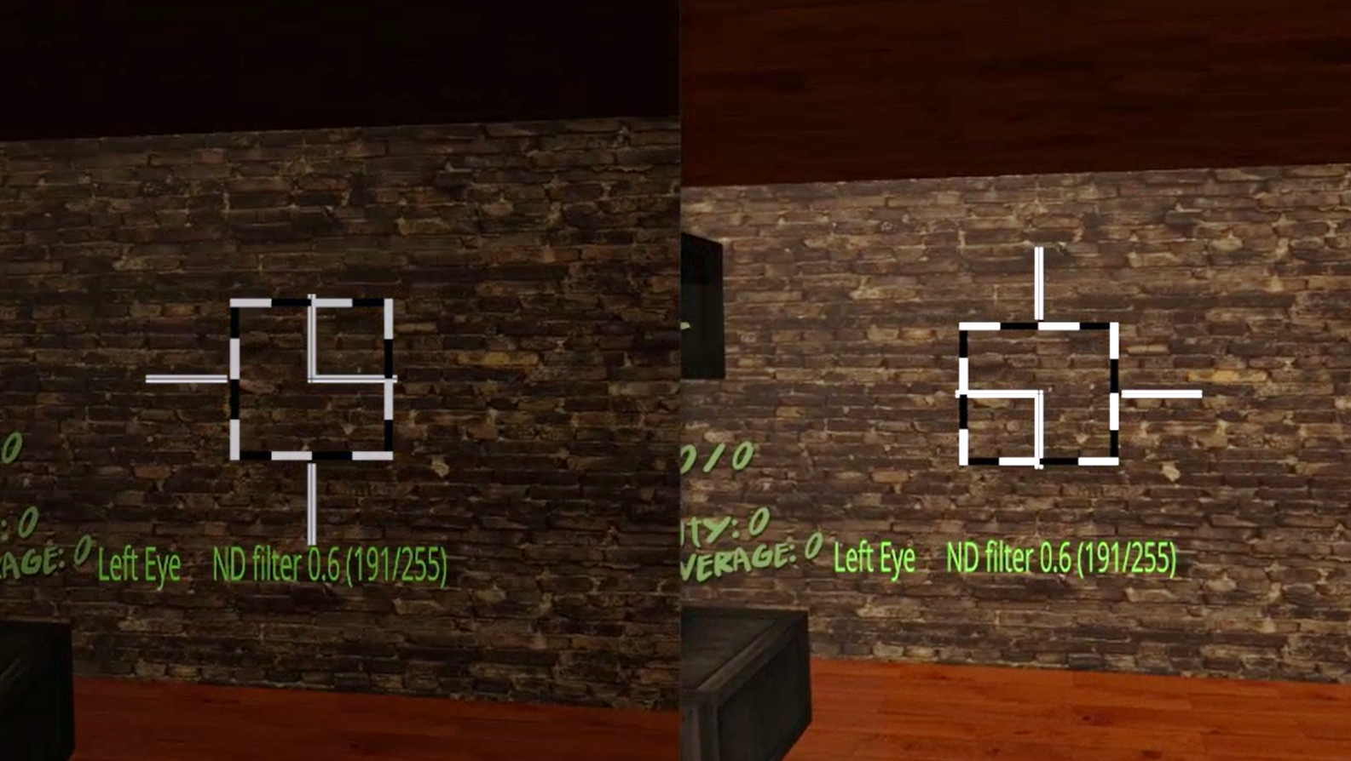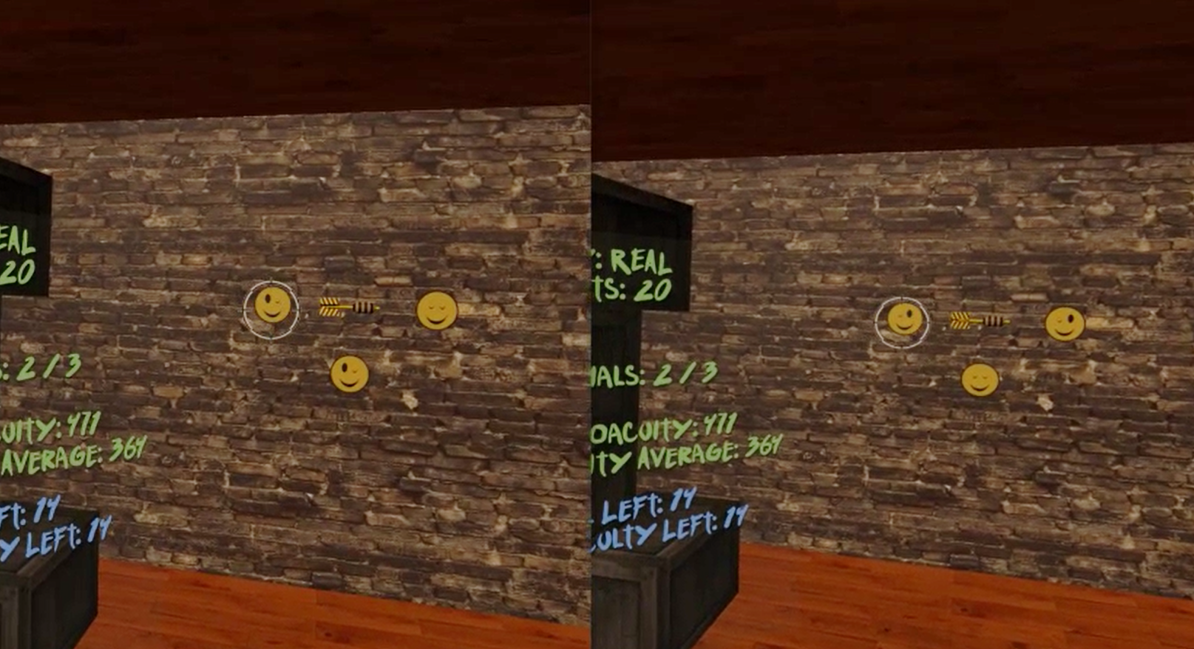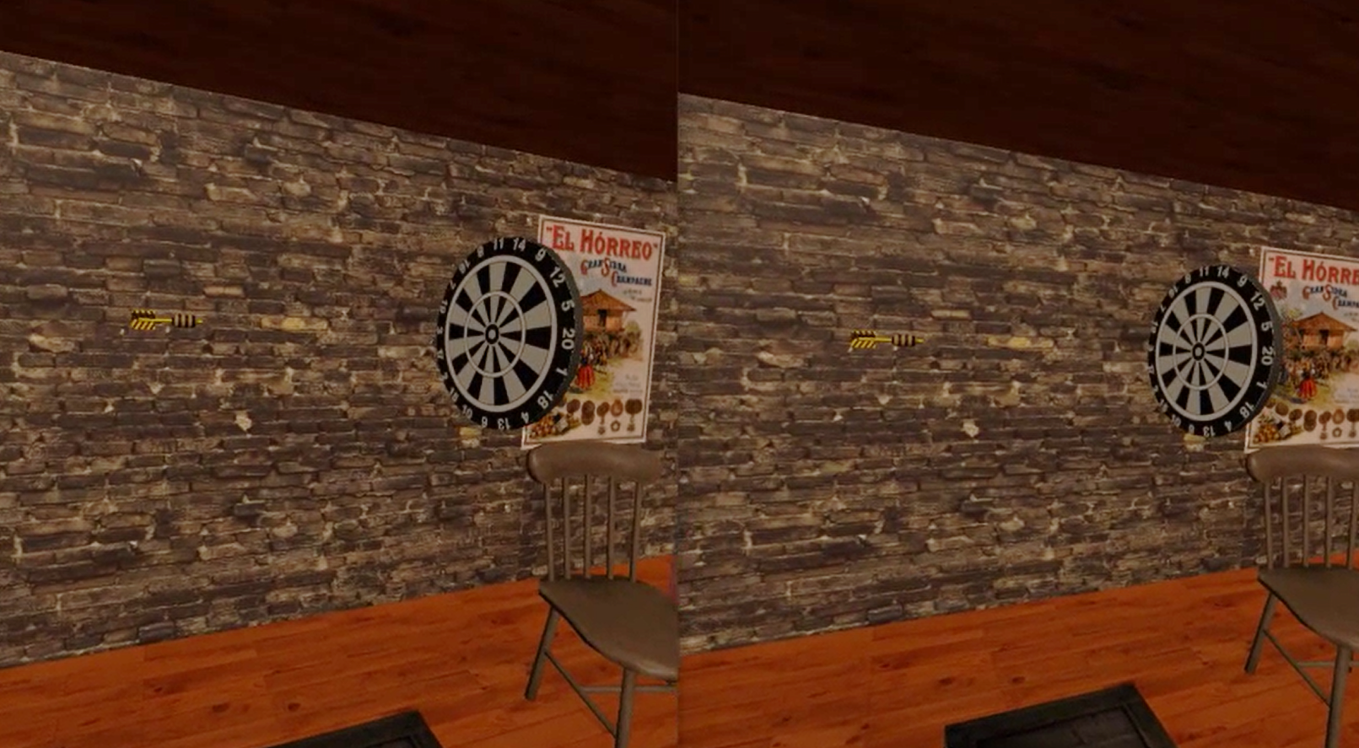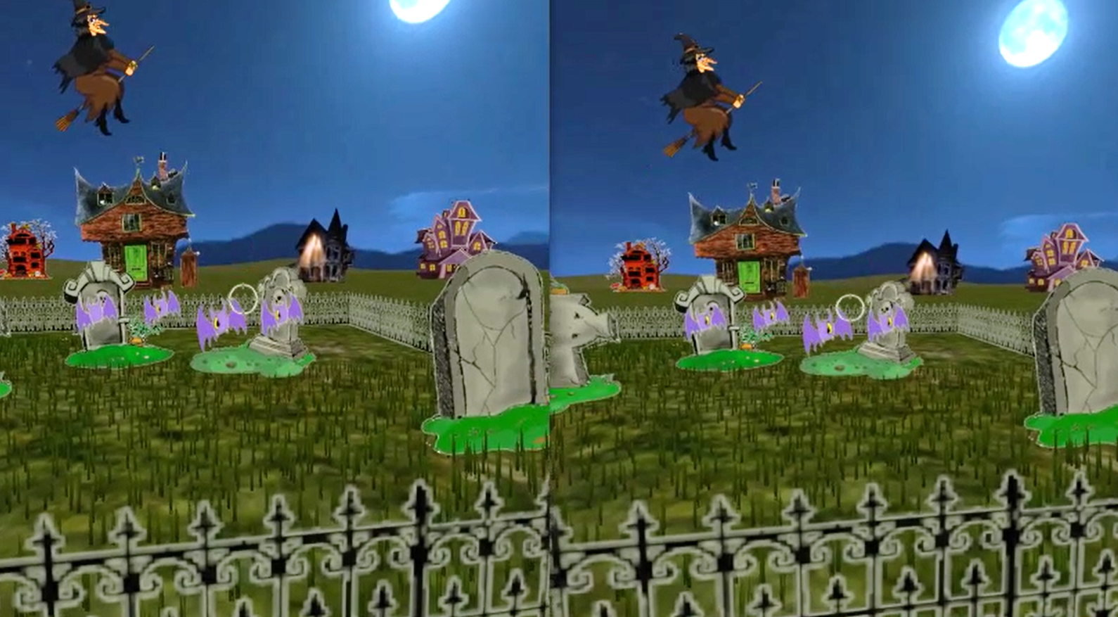

Figure 2. DartBoard and Halloween game screenshots. Top left: Fusion-lock frame calibration for DartBoard (same for Halloween, except the background) to eliminate subjective misalignment angles. Top right: DartBoard 3-AFC suppression test. Bottom left: Example of DartBoard trial. Bottom right: Example of Halloween trial.

Cue scaffolding was implemented in both games, creating three consecutive cues scaffolding conditions (Condition 1, 2, and 3), which progressively eliminate non-stereoscopic depth cues, from an up-to-date VR scene (where accommodation is the only depth cue not simulated) to a scene where only retinal disparity was available. Each session began with Condition 1, which consisted of monocular and binocular cues to depth including shadows, perspective, motion parallax, and binocular disparity. In Condition 2, shadows were eliminated and perspective reduced- meaning, relative size was no longer a reliable cue (i.e., object size was not relative to object distance). Lastly, in Condition 3, motion parallax was limited (only rotational movements of the head were allowed by the software), making binocular disparity the most helpful (almost unique) cue to calculate distance.

A 3-AFC suppression test (by means of dichoptic images) was also inserted in each games’ mechanics to help participants become aware of suppression episodes. For example, in the DartBoard game, participants were instructed to identify the smiley face in a set of three with both eyes open, which could only be seen if binocular fusion was maintained (Figure 2- Top right). In the Halloween game, participants were instructed to eliminate all targets with both eyes open and avoid targets with one eye, which again could only be achieved if binocular fusion was maintained. Importantly, the purpose of the suppression tests was to bring awareness of suppression to participants who actively suppressed. Suppression test failures were registered in both game result files.

Game mechanics and respective in-game measurements were different in each game. In DartBoard, participants were instructed to launch a dart, which was presented at the center of the screen, towards a dartboard that travelled from the back of the participant and moved towards the background of the scene (Figure 2- Bottom left). Each dart launch constitutes a trial. Movement of the dart once launched, was always linear and traveled from left to right, while movement of the board was linear, but not necessarily at a 90° angle or at the same speed of the dart. Both linear movements occurred in the same plane where the observers’ eyes were. Thus, there was no way of guessing the intersection of both trajectories using monocular cues. The movement of the dart board was designed to stop at intervals in order to facilitate the exercise. The perceptual learning task for the participant was estimating, using the background wall as reference, when the dart (stationary object) and the dart board (object moving in depth) were at the same distance (i.e. accuracy could theoretically be as low as zero arc secs). In Halloween, the participant was instructed to shoot the closest target in a variable set of targets (three to seven phantoms, pumpkins or vampires) as they approached the participant (Figure 2- Bottom right). Each shoot constitutes a trial. Similar to the movement of the dartboard, the approaching targets stopped at intervals to facilitate the exercise. Importantly, relative parallax between the targets were constant, and decreased across trials from 1000” to 400” over time, depending on the participants’ performance. Therefore, the perceptual learning task in Halloween was to determine the relative distance between several objects. It is important to note that DartBoard in-game measurements result in accuracy threshold values for each trial at each cue scaffolding condition; while Halloween in-game measurements result in the proportion of correct responses for each stereo demand at each condition.

**Data Analysis**

Differences between stereo-anomalous and stereo-normal groups or cue scaffolding conditions were calculated through means comparison. Analysis of variance was used to establish differences between variables with more than two levels of comparison. ANOVA was used for normal distribution variables and Kruskal-Wallis when distributions were not normal. Two samples comparison was made using t-Student test if normal distribution is confirmed and Wilxoco-Mann-Whitney otherwise. Kolmogoro-Simirnov test was used to confirm normal distribution of variables. Relationship between variables was made through Pearson correlation test. Significance level was set to 0.05. The software used has been R-Statistics (v3.6.3).

**RESULTS**

**In-game performance accuracy**

DartBoard game provided 102,252 data points corresponding to the activity of the 20 participants. This gave approximately 80 launches per hour of gameplay and condition. Examples of the results collected from participant are shown in Figure 3. Each dot represents the in-game acuity threshold obtained after one hour of game play. Each cue scaffolding conditions (game levels 1, 2 and 3) is represented by a different symbol. An exponential fitness curve (that will be explained afterwards in this chapter) is also included.

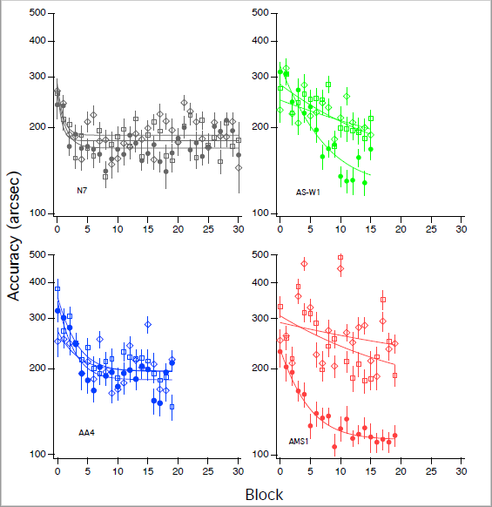

Figure 3. Examples of DartBoard in-game performance accuracy for four participants, one stereo-normal (figure 3-A, participant N7) and three stereo-anomalous: figure 3-B, stereo-weak participant AS-W1; figure 3-C, anisometropic participant AA4; and figure 3-D, strabismic participant AMS1. Condition 1 is represented solid circles, Condition 2 as hollow squares and Condition 3 as hollow diamonds.

Kolmogorov-Smirnov test shows that DartBoard game results don’t follow a normal distribution analyzed as a whole, neither considering the six subgroups obtained considering participant group (stereo-anomalous and stereo-normal) and cue scaffolding conditions (level 1, 2 and 3) (p-values = 0.000 in all cases). Therefore, non-parametric test will be used for the following analysis.

Means and confidence intervals (calculated using Bootstrap method) for each group and condition are shown in Table 1.

Table 1. DartBoard in-game acuity. Means and confidence intervals, calculated using Bootstrap method, for each group and condition considered. Values in seconds of arc.

|  |  |  |
| --- | --- | --- |
| Condition | Stereo-normal | Stereo-anomalous |
| Level 1 | 184 [183,186] | 201 [199,203] |
| Level 2 | 190 [188,192] | 234 [231,236] |
| Level 3 | 191 [190,193] | 240 [238,243] |

Kruskal-Wallis test shows that stereo-normal results are different from stereo-anomalous (p-values = 0.000 in both groups). The mean comparison between each pair of cue scaffolding conditions for both groups, stereo-normal and stereo-anomalous, (Mann-Whiney test) show that Level 1 and Level 2 results are different for both groups (p-values = 0.000 in both); and also are Level 1 and Level 3 results (p-values = 0.000 in both). When comparing Level 2 and Level 3 results, mean values are different for stereo-anomalous group (p-value = 0.006) but not for stereo-normal group (p-value = 0.534). The mean comparison between each group, stereo-normal and stereo-anomalous, at each cue scaffolding condition (Level 1, 2 or 3), using Mann-Whiney test, show that results are different for both groups at each condition (p-values = 0.000 in the tree conditions).

The results obtained by each patient have been adjusted using an exponential fitness (equation 1). From the fit, we calculated the asymptotic final threshold, time constant, and the ratio of baseline to asymptotic threshold (PPR) for each participant. The asymptotic final threshold represents the best performance achieved through training. The time constant represents the time it took for the exponential to fall 37% (1/e) of the starting value. Thus, it represents the rate of learning. Lastly, the PPR represents the amount of learning as a factor of the starting threshold (higher PPR indicates greater learning).

Equation 1. $\left(PPR×e^{-\frac{\# of sessions}{Time constant}}+1\right)×asymptotic threshold$

Mean values and confidence intervals of each parameter per condition and group are shown in Table 2. Results of participants N5, N10 and AS2 have been removed, as exponential fitness results in outliers in time constant parameter. According to these results, final threshold seems to be bigger for stereo-anomalous group and condition level 3. PPR seems to be more dependent of condition level in stereo-anomalous group, decreasing with level. Finally, time constant seems also to be more dependent on condition level for stereo-anomalous group, reaching bigger values in level 3.

Table 2. DartBoard in-game acuity, after exponential fitness: PPR, asymptotic threshold and time constant. Means and confidence intervals, calculated using Bootstrap method, for each group and condition considered. Threshold values in seconds of arc.

|  |  |  |  |
| --- | --- | --- | --- |
| Variable | Condition | Stereo-normal | Stereo-anomalous |
| PPR | Level 1 | 1.8 [1.5,2.0] | 1.9 [1.7, 2.1] |
|  | Level 2 | 1.8 [1.4,2.1] | 1.7 [1.4,1.9] |
|  | Level 3 | 1.8 [1.4,2.2] | 1.5 [1.3,1.6] |
| Threshold | Level 1 | 162 [146,186] | 174 [149,201] |
|  | Level 2 | 166 [142,199] | 200 [153,251] |
|  | Level 3 | 172 [151,197] | 202 [160,250] |
| Time | Level 1 | 10.2 [3.6,18.3] | 5.0 [2.9,6.3] |
| Constant | Level 2 | 6.3 [1.2,10.1] | 9.8 [2.9,15.2] |
|  | Level 3 | 7.7 [1.0,12.7] | 16.4 [6.9,24.9] |

PPR results show that all participants of stereo-anomalous group improve in all cue scaffolding conditions, as most stereo-normal participants do. Only N3 in condition level 3 (PPR = 0 0.95) and N5 in condition level 2 (PPR = 0.97) fail. PPR analysis using Kruskal-Wallis test show that there are not statistically significant differences due to condition for stereo-normal group (p-value = 0.845), meaning that stereo-normal participants behave similar in the three conditions. Meanwhile, stereo-anomalous group shows statistically significant differences due to condition (p-value = 0.037), that are also (and only) significant when we compare cue scaffolding conditions 1 and 3 (p-value = 0.009), meaning that stereo-anomalous participants behaves different in both conditions. Mann-Whiney test doesn’t show any statistically significant difference between groups in any of the three conditions, meaning that in any of tree cue scaffolding conditions the behavior of both groups is similar.

The other two parameters obtained in the exponential fit, final threshold and time constant, fail to show any statistically significant difference in any analysis.

We analyze the correlation (Pearson) between the PPR and initial threshold (instead of final) as obtained in the exponential fitness (Table 3). We found a moderate or high correlation for stereo-normal participants in all conditions, that is statistically significant in condition 1 and 3. Meanwhile stereo-anomalous participants behave different, showing an inverse or null correlation in conditions 2 and 3. This different behavior is even more evident if we consider all three cue scaffolding conditions together, obtaining a significant correlation and strong correlation in stereo-normal group (0.6510, p-value =0.000) whereas correlation is weak and not statistically significant in stereo-anomalous group (0.0763, p-value=0.694). When all participants are considered, results of stereo-normal group are prevalent.

Table 3. DartBoard results. Analysis of exponential fitness parameters. PPR and initial threshold correlation using Pearson test for each cue scaffolding condition and all conditions together.

|  |  |  |  |  |  |  |
| --- | --- | --- | --- | --- | --- | --- |
|  | Stereo-normal | | Stereo-anomalous | | All participants | |
| Condition | Correlation | p-value | Correlation | p-value | Correlation | p-value |
| Level 1 | 0.5616 | 0.091 | 0.3775 | 0.282 | 0.4750 | 0.034 |
| Level 2 | 0.5255 | 0.146 | -0.0670 | 0.854 | 0.2088 | 0.391 |
| Level 3 | 0.7655 | 0.016 | -0.3572 | 0.345 | 0.4769 | 0.045 |
| All levels | 0.6510 | 0.000 | 0.0763 | 0.694 | 0.3815 | 0.003 |

We finally perform a comparison between initial threshold and PPR relative to condition. The idea behind this analysis is to compare the improvements in cue scaffolding condition 1, where all depth cues are available, vs condition 3, where only retinal disparity is available. Those improvements may be different if initial thresholds are different for both conditions. Even the improvement may be depending on initial threshold. A participant who exhibits good in-game acuity when all depth cues are available (level 1) but performs poorly when only retinal disparity is present (level 3), is perhaps likely to improve more in level 3 than in level 1 after treatment. I.e. the lower the initial threshold ratio between level 1 and level 3, the lower the PPR ratio between level 1 and 3. In Figure 4 each participant is represented as an arrow, whose start point is the initial accuracy threshold, in level 1 for horizontal axis and Level 3 for vertical axis. Arrow horizontal length is proportional to the improvement (PPR) in the use of all depth cues when available (Level 1), whereas vertical length is the improvement in the use of retinal disparity alone (Level 3). All arrows point towards a game accuracy limit threshold that is located in the lower left corner of the graph. Stereo-normal participant’s arrows point to that threshold, independently if their start point is below or above the 45 degrees line. Nevertheless, stereo-anomalous participants are represented by an arrow that always shows an angle of improvement lower than 45 degrees, i.e. the improvement attributable to the use of retinal disparity is lower than the improvement attributable to the use of all depth cues together.

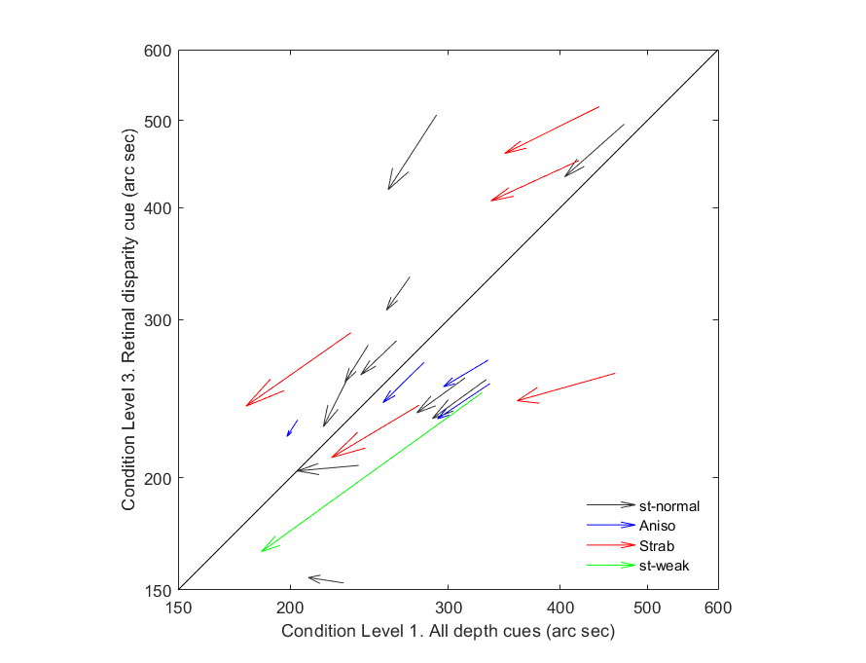

Figure 4. DratBoard in-game accuracy initial thresholds and PPR in two cue scaffolding conditions (Level 1 vs Level 3). Each participant is represented as an arrow, whose start point is the initial accuracy threshold, whose horizontal length the improvement in game accuracy (Level 1), and whose vertical length is the improvement in game accuracy (Level 3). Length of the arrows is escalated to facilitate identification of arrow direction, i.e. end point does not fit final threshold. Arrows whose start point is under the diagonal unity line show a better initial performance when all depth cues are present compared with the performance when only retinal disparity is available. Arrows whose angle is lower than 45 degrees show a bigger improvement for near to natural depth perception condition than for stereoacuity alone. Stereo-normal participants are represented in black, stereo-anomalous are represented in different colors depending on subclassification: anisometropic in blue, strabismic in red, stereo-weak in green.

This interpretation of the graph is analyzed statistically. We find that PPR ratio between condition 1 and 3 correlates (Pearson’s test) strongly with initial threshold ratio in both stereo-normal (0.7233) and stereo-anomalous groups (0.5448), but the correlation is statistically significant in stereo-normal group (p-value = 0.018) and not in stereo-anomalous (p-value = 0.103).

The second game, Halloween, provides different results. As previously explained, Halloween in-game measurements result in the proportion of correct responses for each stereo demand at each cue scaffolding condition on each session. Stereo demand takes the values 1000, 800, 600, and 400 arc seconds. In order to measure improvements, we compare the proportion of right answers of the first 4 sessions (4 hours of game play) vs the last 4 sessions, for each participant at each condition. Those results are grouped, taking the mean values, into stereo-normal and stereo-anomalous, i.e. anisometropic, strabismic and stereo-weak (Figure 5). Values above the 45 degrees line indicate an improvement in terms of error reduction.

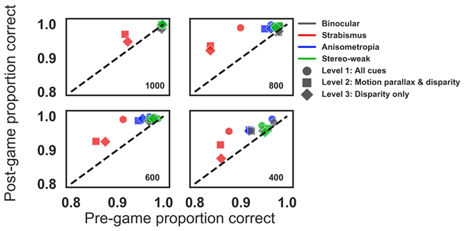

Figure 5. Halloween pre to post proportion correct for disparity values of 1000, 800, 600, and 400 arc seconds. Each symbol represents a different clue scaffolding condition (level 1, circles; level 2, squares; and level 3, diamonds) for participants with anisometropia (blue), strabismus (red), stereo-weak (green), and normal binocular (grey). Points above the unity line indicate a reduction of errors in the last six blocks compared to the first six blocks.

**Clinic and** **psychophysical test**

Pre and post results obtained by participants, grouped as stereo-normals and stereo-anomalous, are shown in Figure 6. Figure 6A shows Randot Circles Stereotest® (open symbols) and Random Dot 3 Stereo Acuity Test with Lea Symbols® (filled symbols). Figure 6B is obtained with psychophysical test: PDT (triangle), RDS small (small circle), RDS medium (medium circle) and RDS big (big circle). In both figures, colors indicate binocular condition: anisometropia (blue), strabismus (red), stereo-weak (green), and normal stereo (grey). Data under the diagonal unity line indicate an improvement in stereoacuity

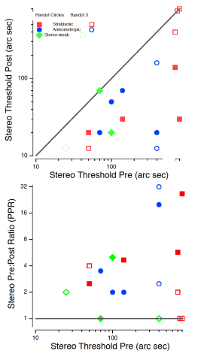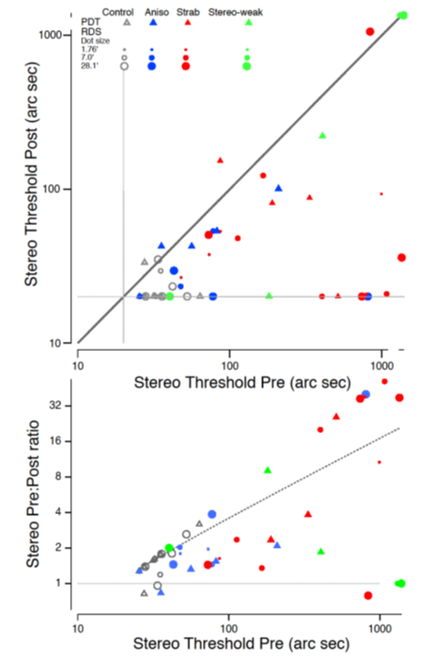

Figure 6. (A) Clinical stereoacuity improvement as a function of initial Randot Circles Stereotest® and Random Dot 3 Stereo Acuity Test with Lea Symbols®. Open symbols are used for Random Dot 3 where filled symbols for Randot Circles. (B) Psychophysical stereoacuity improvement as a function of initial stereo threshold. Each symbol represents a psychophysical test: PDT (triangle), RDS small (small circle), RDS medium (medium circle) and RDS big (big circle). In both figures, colors indicate binocular condition: anisometropia (blue), strabismus (red), stereo-weak (green), and normal stereo (grey). Data under the diagonal unity line indicate an improvement in stereoacuity.

Statistical analysis starts analyzing mean differences for each test results (before and after treatment) between stereo-normal and stereo-anomalous groups (Table 4). We find statistically significant differences between groups for all test, but DDR small pre- treatment (p-value = 0.052) and DDR big post- treatment (p-values = 0.100).

Table 4. Mean stereoacuity results obtained with each test before and after treatment, for stereo-normal and stereo-anomalous patients. Values in seconds of arc.

|  |  |  |  |  |
| --- | --- | --- | --- | --- |
|  | Stereo-normal | | Stereo-anomalous | |
|  | pre | post | pre | post |
| Randot Circles | 20 | 20 | 129 | 37 |
| Random Dot 3 | 13 | 13 | 339 | 105 |
| PDT | 30 | 22 | 155 | 63 |
| DRS small | 23 | 20 | 105 | 45 |
| DRS medium | 22 | 21 | 129 | 50 |
| DRS big | 28 | 21 | 263 | 62 |

Clinic tests show a clear improvement in stereoacuity for stereo-anomalous participants, as Table 5 resumes, but that improvement is not detected in stereo-normal group. Meanwhile, psychophysical tests confirm the improvement of stereo-anomalous participants and, importantly, also show improvements of stereo-normal participants.

Table 5. Clinic and Psychophysical test results. Participants where initial value is equal or bigger than after treatment, and participants where initial value is strictly bigger than final value (both stereo-normal group and stereo-anomalous group have N=10)

|  |  |  |  |  |
| --- | --- | --- | --- | --- |
|  | Stereo-normal | | Stereo-anomalous | |
|  | Initial ≥ Final | Initial > Final | Initial ≥ Final | Initial > Final |
| Randot Circles | 10 | 0 | 10 | 9 |
| Random Dot 3 | 10 | 0 | 10 | 7 |
| PDT | 8 | 7 | 8 | 8 |
| DRS small | 10 | 3 | 10 | 6 |
| DRS medium | 9 | 2 | 10 | 7 |
| DRS big | 9 | 4 | 9 | 7 |

In the stereo-anomalous group, participant AMS1, with micro strabismus, fails to improve according to both clinic tests, although both PDT and DRS small show an improvement. Participants AS1, with strabismus, fail to improve according to Random Dot 3, but improves according to the other tests. Participant AS2, also in the strabismic group, doesn’t exhibit improvement with Random Dot 3, neither with PDT, but shows improvements with the other tests. Finally, results in PDT test of participants AA3 (anisometropic) and AS2 exhibit a regression, but they improve according to other tests.

Seven up to ten participants in the stereo-normal group showed improvements in the PDT test: N9 and N10 exhibited a regression and N1 was at ceiling. Also, DRS test detected in seven up to ten participants improvements: N3 and N5 were at ceiling and N2 exhibited a narrow regression in DRS big. Those improvements were not detected by the clinical tests because all stereo-normal participants were at ceiling before the treatment.

We also analyze if these tests show any correlation between the initial stereoacuity value and the PPR. We perform the correlation considering the whole dataset of participants and also divided in the two groups (Table 6). All tests but Randot Dot 3 in stereo-anomalous group show a positive correlation, meaning that the higher the initial value (stereoacuity deficit) the higher the PPR (percentage of improvement). Nevertheless, significance fails in the stereo-anomalous group.

Table 6. Correlation coefficients and p-values using Pearson test between PPR and initial stereoacuity values, considering groups stereo-normal and stereo-anomalous, and all participants. Clinic tests fail to show valid data in stereo-normal group, as all results were at ceiling.

|  |  |  |  |  |  |  |
| --- | --- | --- | --- | --- | --- | --- |
|  | Stereo - normals | | Stereo - anomalous | | All participants | |
|  | Correlation | p-value | Correlation | p-value | Correlation | p-value |
| Randot Circles | - | - | 0.4852 | 0.155 | 0.7812 | 0.000 |
| Random Dot 3 | - | - | -0.1770 | 0.625 | 0.3653 | 0.113 |
| PDT | 0.9225 | 0.000 | 0.6317 | 0.050 | 0.6118 | 0.004 |
| DRS small | 1.000 | 0.000 | 0.5715 | 0.084 | 0.6413 | 0.002 |
| DRS medium | 0.8249 | 0.003 | 0.4719 | 0.169 | 0.5918 | 0.006 |
| DRS big | 0.8792 | 0.000 | 0.4870 | 0.153 | 0.6285 | 0.003 |

Finally, we analyze if there is a correlation between the DartBoard in-game acuity performance and the clinic and psychophysics tests (Table 7). We are interested mainly in condition 3, where only retinal disparity clue is available. For this analysis, we compare pre- and post- thresholds obtained by each participant in DartBoard using the exponential fitness explained before with the pre- and post- test results. We consider only stereo-anomalous participants, as stereo-normal are all at ceiling. We find medium to high correlation in all cases. The correlation value obtained with Randot Circles is bigger than the correlation found between Randot Circles and any other clinical and psychophysical test used in this study.

Table 7. Correlation coefficients and p-values using Pearson test between DartBoard in-game acuity performance in condition level 3, clinical tests (Randot Circles Stereotest® and Random Dot 3 Stereo Acuity Test with Lea Symbols®) and psychophysical tests (PDT, RDS small, RDS medium and RDS big).

|  |  |  |  |  |  |  |
| --- | --- | --- | --- | --- | --- | --- |
|  | Randot  Circles | Random  Dot 3 | PDR | RDS  small | RDS  medium | RDS  big |
| correlation | 0.6988 | 0.7329 | 0.5182 | 0.4381 | 0.3421 | 0.5397 |
| p-value | 0.000 | 0.000 | 0.019 | 0.053 | 0.140 | 0.014 |

**DISCUSSION**

* In summary, our preliminary results show that most of the stereo deficient players improved in the game and showed transfer to both clinical and psychophysical tests (Table 5).
* By its own these results confirm the viability of recovering stereoacuity by means of videogames, as previous studies have stated before (Ding & Levi, 2011; Levi et al., 2015b; Vedamurthy et al., 2016; Xi et al., 2014), despite the different design and nature of the activities used in this work.
* The small sample size does not allow to confirm statistically any difference between stereo-anomalous subgroups. Nevertheless, participants who do not show improvement in some tests are AS1, AS2, AA3 and ASM1, all with strabismus except AA3, with anisometropia.
* Anisometropic patients retain stereoacuity at low frequencies (Levi et al., 2011). Although their stereoacuity is not as acute as normal, it is nevertheless functional. Thereby, anisometric patients are more likely to recover stereoacuity after a PL treatment.
* On the other hand, stereoacuity is more impaired by strabismus than by anisometropia (Levi et al., 2015b). Suppression scotoma may be different, active to avoid diplopia instead of passible due to the visual loss in anisometropia. Strabismus is more refractive to stereoacuity treatments.
* Participants AMS1, AS1 and AS2 (all strabismic) experienced no improvement when measured with Random Dot 3, but they do improve when measured with other tests. Random dot stimuli are more affected by any subtle binocular deviation angle (Birch & Wang, 2009). Participant ASM1, with micro-strabismus, is likely to have developed a harmonious anomalous correspondence [ref3]. If that happens, neural binocular connections are present but are not as acute as in normal correspondence. PL learning cannot go beyond that neural limitation, unless anomalous correspondence is treated before.
* Regarding stereo-normal group, most of them have detectable improvements through psychophysical tests. Those improvements were not detected by the clinical tests because all stereo-normal participants were at ceiling before the treatment.
* Previous research has pointed out improvements in stereoacuity functions for normal vision subjects after training (Vedamurthy et al., 2016). Certain professions as dressmakers, where specific stereo demanding tasks are common, show enhanced stereoacuity (Chopin et al., 2017). There is a reasonable doubt about what the reason is, if good stereoacuity is a condition that has to fulfill the candidate to dressmaker or if the dressmaker enhances its skill due to those stereo demanding tasks. Our result points out that stereoacuity can be improved even when baseline conditions are normal-vision.
* We have not detected transfer to visual acuity in the participants.
* Improvements in stereoacuity after training are not necessarily transferred to visual acuity according to previous studies (Jian Ding & Levi, 2011; Vedamurthy et al., 2016; Xi et al., 2014).
* Anyway, current state of the art VR headsets has a lack of resolution that makes them not the best tool to train visual acuity.
* According to both clinical and psychophysical tests, participants with a higher (worse) initial stereo threshold show a higher stereo PPR, meaning they improved more after training (Table 6). Nevertheless, this correlation is even inverse when considering stereo-anomalous group alone. DartBoard in-game performance exhibit the same trends (Table 3). It seems that basal stereoacuity deficit does not predict the improvement after the training.
* Accordingly, a recent paper based on the results of PL stereo training using random dot (RDT) stimuli with patients with a history of amblyopia, has found a strong inverse association between the initial stereoacuity measurements and the percentage of stereoacuity improvement [ref 15].
* A similar trend has been found in the recovery of visual acuity: previous studies concluded that basal acuity loss also does not predict the improvement in acuity after dichoptic training (Mansouri et al., 2014).
* Baseline stereoacuity threshold, on the other hand, might influence the speed of learning. Previously cited study about stereopsis recovery by means of random dot training [ref 15] detected a positive association between the stereoacuity baseline value and the number of sessions required for successful learning.
* We have not detected neither transfer to a lower visual angle deviation in the strabismic participants.
* Despite both games require the participant to diverge (Dartboard) or converge (Halloween) to moving targets. There is high scientific evidence of the success of training convergence insufficiency [ref7]. The small sample in our study may justify the inconclusive results regarding effects on deviation angles.
* We have not measured binocular imbalance in this study. It would be worth to implement in the future a binocular imbalance test in the same VR device. This would allow to track binocular vision beyond stereoacuity function. Anti-suppression therapy by means of dichoptic games has little or no effects in stereoacuity according to previous studies (Holmes et al., 2016; Kelly et al., 2018; Webber et al., 2016) whereas there are not studies yet, as far as we know, demonstrating if direct stimulation of stereoacuity contributes or not to re-balance vision.
* In fact, it has been suggested that improved stereoacuity after PL might reflect a decrease of interocular suppression (Xi et al., 2014), although it could also be the result of an enhancement of the signal in the amblyopic eye. Moreover, it might not occur at an early level of visual processing (Sowden et al., 1996).
* Although gamification contributes to the improvement of patient’s motivation, attention and compliance, it does it to a cost. In-game results are not as accurate to track patient’s evolution as the results obtained in a traditional PL task.
* Nevertheless, results obtained by DartBoard game in this study demonstrate statistically its coherence with clinical and psychophysical tests.
* Firstly, in-game acuity performance in condition level 3 correlates with clinic and psychophysical tests, in all three conditions (Table 7). Moreover, the correlation value obtained with Randot Circles is bigger than the correlation found between Randot Circles and any other clinical and psychophysical test used in this study. The explanation can be as easy as DartBoard game task (also Halloween) is more similar to a local stereoacuity test like Randot Circles than to any of the other tests.
* Secondly, in-game performance allows to differentiate stereo-normal vs stereo-anomalous participants (and not only in condition level 3, but in all three conditions).
* Thirdly, improvement in condition level 3, where only retinal parallax cue is available, is detected in almost all participants but two stereo-normal (PPR > 1).
* Although those tendencies are coherent with the clinical and psychophysical tests, when we look at the in-game acuity performance values obtained we realize that the DartBoard game only provides a coarse value of stereoacuity (Table 1). Stereo-normal mean in-game performance is 191 arc seconds (condition level 3), whereas always bellow of 30 arc seconds with any of the clinic and psychophysical tests used (Table 3). Nevertheless, the differences are lower in stereo-anomalous group: mean value of 240 arc seconds in level 3 seems reasonable when we compare with tests pre- and post- values.
* Halloween game does not provide such rich data, because lower stereoacuity demand was set to 400”.
* In these conditions, it’s reasonable to affirm that PL training has taken place at threshold for most stereo-anomalous participants in DartBoard and slightly above threshold in Halloween, whereas clearly above threshold for stereo-normal participants. Nevertheless, they improve.
* When designing a PL task, above threshold activities are not considered, as whatever activity would become (even) less interesting and engaging [ref2]. Nevertheless, at least one study has reported improvements in stereoacuity in a control group whose activity was chosen to be above threshold [ref0]. In that case the improvement was attributed to the stimuli used, random dot, which maybe improves binocular fusion and noise to signal discrimination. Those aspect are especially important for strabismic patients. Although the task used in our study is different, it is also true that our scheme takes advance of virtual reality to improve binocular alignment.
* Finally, the novelty of this study is the use of a cue scaffolding approach for the treatment. We have demonstrated, firstly, that cue scaffolding is present: in-game performance is statistically different for each condition, no matter if participant belongs to stereo-normal or stereo-anomalous group (with the exception of condition level 2 and 3 for stereo-normal group).
* Differences are more notable between condition 1 (almost all depth cues available) and condition 3 (only retinal disparity). Some participants exhibited at the beginning of the study better depth discrimination when all depth cues are present than when only retinal disparity is available, but others did the other way (Figure 4). And there is not any effect of group membership. Stereo-normal participants tendency, demonstrated statistically, is to improve more in the condition where they show initially lower skills. Nevertheless, stereo-anomalous group tendency is different. They improved more in the ability to integrate all depth cues than in stereoacuity considered as a single depth signal.
* Previous studies (Vedamurthy et al., 2016) demonstrated that repetitive tasks with high depth perception demand contribute to increase the weight of disparity cue in adults deprived of normal binocular vision, although they don’t achieve the same levels as normal control subjects. In situations where disparity depth valuation is contradictory with other depth cues, as texture, the weight of disparity in the final estimation increases after treatment.
* Our study unveils that sensory integration (condition level 1) is less reluctant to improvements than just disparity depth perception (condition level 3). This might explain the reports of patients regarding better depth perception after visual therapy treatments not correlated with measurable stereoacuity improvements (Tidbury et al., 2014).
* CAN WE ADD SUBJECTIVE VALORATION OF SUBJECTS? DO THEY FELL ANY IMPROVEMENT?

**REFERENCES**

Adams, W. J., Graf, E. W., & Anderson, M. (2019). Disruptive coloration and binocular disparity: Breaking camouflage. *Proceedings of the Royal Society B: Biological Sciences*, *286*(1896). https://doi.org/10.1098/rspb.2018.2045

Atkins, J. E., Fiser, J., & Jacobs, R. A. (2001). Experience-dependent visual cue integration based on consistencies between visual and haptic percepts. *Vision Research*, *41*(4), 449–461. https://doi.org/10.1016/S0042-6989(00)00254-6

Banks, M. S., Aslin, R. N., & Letson, R. D. (1975). Sensitive Period for the Development of Human Binocular Vision Author. In *New Series* (Vol. 190, Issue 4215).

Birch, E. E. (2013). Amblyopia and binocular vision. *Progress in Retinal and Eye Research*, *33*(1), 67–84. https://doi.org/10.1016/j.preteyeres.2012.11.001

Birch, E. E., & Wang, J. (2009). Stereoacuity outcomes after treatment of infantile and accommodative esotropia. In *Optometry and Vision Science* (Vol. 86, Issue 6, pp. 647–652). https://doi.org/10.1097/OPX.0b013e3181a6168d

Chopin, A., Levi, D. M., & Bavelier, D. (2017). Dressmakers show enhanced stereoscopic vision. *Scientific Reports*, *7*(1). https://doi.org/10.1038/s41598-017-03425-1

Ding, J., & Levi, D. M. (2011). Recovery of stereopsis through perceptual learning in human adults with abnormal binocular vision. *Proceedings of the National Academy of Sciences*, *108*(37), E733–E741. https://doi.org/10.1073/pnas.1105183108

Ding, Jian, & Levi, D. M. (2011). Recovery of stereopsis through perceptual learning in human adults with abnormal binocular vision. *Proceedings of the National Academy of Sciences*, *108*(37), 733–741. https://doi.org/10.1073/pnas.1105183108

Ding, Jian, & Levi, D. M. (2014). Rebalancing binocular vision in amblyopia. *Ophthalmic and Physiological Optics*, *34*(2), 199–213. https://doi.org/10.1111/opo.12115

Ernst, M. O., & Banks, M. S. (2002). Humans integrate visual and haptic information in a statistically optimal fashion. *Nature*, *415*, 429–433. papers3://publication/uuid/F5A0DA65-72CA-4E88-A49C-2BDA6BF8E47F

Ernst, M. O., Banks, M. S., & Bülthoff, H. H. (2000). Touch can change visual slant perception. *Nature Neuroscience*, *3*(1), 19–21.

Gao, T. Y., Guo, C. X., Babu, R. J., Black, J. M., Bobier, W. R., Chakraborty, A., Dai, S., Hess, R. F., Jenkins, M., Jiang, Y., Kearns, L. S., Kowal, L., Lam, C. S. Y., Pang, P. C. K., Parag, V., Pieri, R., Raveendren, R. N., South, J., Staffieri, S. E., … Boswell, S. J. (2018). Effectiveness of a binocular video game vs placebo video game for improving visual functions in older children, teenagers, and adults with amblyopia: A randomized clinical trial. *JAMA Ophthalmology*, *136*(2), 172–181. https://doi.org/10.1001/jamaophthalmol.2017.6090

Giaschi, D., Lo, R., Narasimhan, S., Lyons, C., & Wilcox, L. M. (2013). Sparing of coarse stereopsis in stereodeficient children with a history of amblyopia. *Journal of Vision*, *13*(10), 1–15. https://doi.org/10.1167/13.10.17

Held, R., Birch, E., & Gwiazda, J. (1980). Stereoacuity of human infants. *Proceedings of the National Academy of Sciences*, *77*(9), 5572–5574.

Hess, R. F., Mansouri, B., & Thompson, B. (2010). A new binocular approach to the treatment of Amblyopia in adults well beyond the critical period of visual development. *Restorative Neurology and Neuroscience*, *28*(6), 793–802. https://doi.org/10.3233/RNN-2010-0550

Hess, Robert F, Thompson, B., & Baker, D. H. (2014). Binocular vision in amblyopia: Structure, suppression and plasticity. *Ophthalmic and Physiological Optics*, *34*(2), 146–162. https://doi.org/10.1111/opo.12123

Hillis, J. M., Watt, S. J., Landy, M. S., & Banks, M. S. (2004). Slant from texture and disparity cues: Optimal cue combination. *Journal of Vision*, *4*(12), 967–992. https://doi.org/10.1167/4.12.1

Holmes, J. M., & Clarke, M. P. (2006). Amblyopia. *Lancet*, *367*, 1343–1351.

Holmes, J. M., Manh, V. M., Lazar, E. L., Beck, R. W., Birch, E. E., Kraker, R. T., Crouch, E. R., Erzurum, S. A., Khuddus, N., Summers, A. I., & Wallace, D. K. (2016). Effect of a binocular ipad game vs part-time patching in children aged 5 to 12 years with amblyopia a randomized clinical trial. *JAMA Ophthalmology*, *134*(12), 1391–1400. https://doi.org/10.1001/jamaophthalmol.2016.4262

Jacobs, R. A., & Fine, I. (1999). Experience-dependent integration of texture and motion cues to depth. *Vision Research*, *39*(24), 4062–4075. https://doi.org/10.1016/S0042-6989(99)00120-0

Kelly, K. R., Jost, R. M., Wang, Y. Z., Dao, L., Beauchamp, C. L., Leffler, J. N., & Birch, E. E. (2018). Improved binocular outcomes following binocular treatment for childhood amblyopia. *Investigative Ophthalmology and Visual Science*, *59*(3), 1221–1228. https://doi.org/10.1167/iovs.17-23235

Knill, D. C. (2007a). Learning Bayesian priors for depth perception. *Journal of Vision*, *7*(8), 1–20. https://doi.org/10.1167/7.8.13

Knill, D. C. (2007b). Robust cue integration: A Bayesian model and evidence from cue-conflict studies with stereoscopic and figure cues to slant. *Journal of Vision*, *7*(7), 1–24. https://doi.org/10.1167/7.7.5

Knill, D. C., & Saunders, J. A. (2003). Do humans optimally integrate stereo and texture information for judgments of surface slant? *Vision Research*, *43*(24), 2539–2558. https://doi.org/10.1016/S0042-6989(03)00458-9

Levi, D. M., Knill, D. C., & Bavelier, D. (2015a). Stereopsis and amblyopia: A mini-review. *Vision Research*, *114*, 17–30. https://doi.org/10.1016/j.visres.2015.01.002

Levi, D. M., Knill, D. C., & Bavelier, D. (2015b). Stereopsis and amblyopia: A mini-review. *Vision Research*, *114*(2015), 17–30. https://doi.org/10.1016/j.visres.2015.01.002

Levi, D. M., & Li, R. W. (2009). Perceptual learning as a potential treatment for amblyopia: A mini-review. *Vision Research*, *49*(21), 2535–2549. https://doi.org/10.1016/j.visres.2009.02.010

Levi, D. M., McKee, S. P., & Movshon, J. A. (2011). Visual deficits in anisometropia. *Vision Research*, *51*(1), 48–57. https://doi.org/10.1016/j.visres.2010.09.029

Li, R., Polat, U., Makous, W., & Bavelier, D. (2009). Enhancing the contrast sensitivity function through action video game training. *Nature Neuroscience*, *12*(5), 549–551. https://doi.org/10.1038/nn.2296

Li, R. W., Ngo, C., Nguyen, J., & Levi, D. M. (2011). Video-game play induces plasticity in the visual system of adults with amblyopia. *PLoS Biology*, *9*(8). https://doi.org/10.1371/journal.pbio.1001135

Li, X., Dumoulin, S. O., Mansouri, B., & Hess, R. F. (2007). The fidelity of the cortical retinotopic map in human amblyopia. *European Journal of Neuroscience*, *25*, 1265–1277. https://doi.org/10.1111/j.1460-9568.2007.05356.x

Love, G. D., Hoffman, D. M., Hands, P. J. W., Gao, J., Kirby, A. K., Banks, M. S., Matsuki, . M, Kani, H., Tatsugami, F., Yoshikawa, S., Narabayashi, I., Lee, S.-W., Shinohara, H., & Nomura, E. (2009). *High-speed switchable lens enables the development of a volumetric stereoscopic display References and links*. www.displaytech.com

Mansouri, B., Singh, P., Globa, A., & Pearson, P. (2014). Binocular training reduces amblyopic visual acuity impairment. *Strabismus*, *22*(1), 1–6. https://doi.org/10.3109/09273972.2013.877945

Mckee, S. P., & Taylor, D. G. (2010). The precision of binocular and monocular depth judgments in natural settings. *Journal of Vision*, *10*, 1–13. https://doi.org/10.1167/10.10.5.Introduction

Melmoth, D. R., Finlay, A. L., Morgan, M. J., & Grant, S. (2009). Grasping deficits and adaptations in adults with stereo vision losses. *Investigative Ophthalmology and Visual Science*, *50*(8), 3711–3720. https://doi.org/10.1167/iovs.08-3229

Melmoth, D. R., & Grant, S. (2006). Advantages of binocular vision for the control of reaching and grasping. *Experimental Brain Research*, *171*, 371–388. https://doi.org/10.1007/s00221-005-0273-x

Portela-Camino, J. A., Martín-González, S., Ruiz-Alcocer, J., Illarramendi-Mendicute, I., & Garrido-Mercado, R. (2018). A Random Dot Computer Video Game Improves Stereopsis. *Optometry and Vision Science*, *95*(6), 523–535. https://doi.org/10.1097/OPX.0000000000001222

Schoemann, M. D., Lochmann, M., Paulus, J., & Michelson, G. (2017). Repetitive dynamic stereo test improved processing time in young athletes. *Restorative Neurology and Neuroscience*, *35*(4), 413–421. https://doi.org/10.3233/RNN-170729

Sowden, P., Davies, I., Rose, D., & Kaye, M. (1996). Perceptual learning of stereoacuity. In *Perception* (Vol. 25).

Tavers, T. A. (1938). Suppression of vision in squint and its association with retinal correspondence and amblyopia. *The British Journal of Ophthalmology*, 577–604.

Tidbury, L. P., Black, R. H., & O’Connor, A. R. (2014). Perceiving 3D in the absence of measurable stereo-acuity. *Br Ir Orthopt*, *11*, 34–38.

van Beers, R. J., van Mierlo, C. M., Smeets, J. B. J., & Brenner, E. (2011). Reweighting visual cues by touch. *Journal of Vision*, *11*(10), 1–16. https://doi.org/10.1167/11.10.1

Vedamurthy, I., Knill, D. C., Huang, S. J., Yung, A., Ding, J., Kwon, O.-S., Bavelier, D., & Levi, D. M. (2016). Recovering stereo vision by squashing virtual bugs in a virtual reality environment. *Philosophical Transactions of the Royal Society B: Biological Sciences*, *371*(1697), 20150264. https://doi.org/10.1098/rstb.2015.0264

Vedamurthy, I., Nahum, M., Bavelier, D., & Levi, D. M. (2015). Mechanisms of recovery of visual function in adult amblyopia through a tailored action video game. *Scientific Reports*, *5*, 1–7. https://doi.org/10.1038/srep08482

Vedamurthy, I., Nahum, M., Huang, S. J., Zheng, F., Bayliss, J., Bavelier, D., & Levi, D. M. (2015). A dichoptic custom-made action video game as a treatment for adult amblyopia. *Vision Research*, *114*(2015), 173–187. https://doi.org/10.1016/j.visres.2015.04.008

Webber, A. L., & Wood, J. (2005). Amblyopia: prevalence, natural history, functional effects and treatment. *Cinical and Experimental Optometry*, *88*(6), 365–375.

Webber, A. L., Wood, J. M., & Thompson, B. (2016). Fine motor skills of children with amblyopia improve following binocular treatment. *Investigative Ophthalmology and Visual Science*, *57*(11), 4713–4720. https://doi.org/10.1167/iovs.16-19797

Wheatstone, C. (1838). Contributions to the physiology of vision.-Part the first. On some remarkable, and hitherto unobserved, phenomena of binocular vision. *Philosophical Transactions of the Royal Society of London*, *128*, 371–394. https://www.jstor.org/stable/108203

Xi, J., Jia, W. L., Feng, L. X., Lu, Z. L., & Huang, C. B. (2014). Perceptual learning improves stereoacuity in amblyopia. *Investigative Ophthalmology and Visual Science*, *55*(4), 2384–2391. https://doi.org/10.1167/iovs.13-12627